September 29, 2018

FMBC
Regional
Qualifier
Chiefland Middle High School
808 North Main Street
Chiefland, FL 32626
Phone: 352-493-6000
Fax: 352-493-6018

Chiefland Middle High School
808 North Main Street
Chiefland, FL 32626
Phone: 352-493-6000
Fax: 352-493-6018

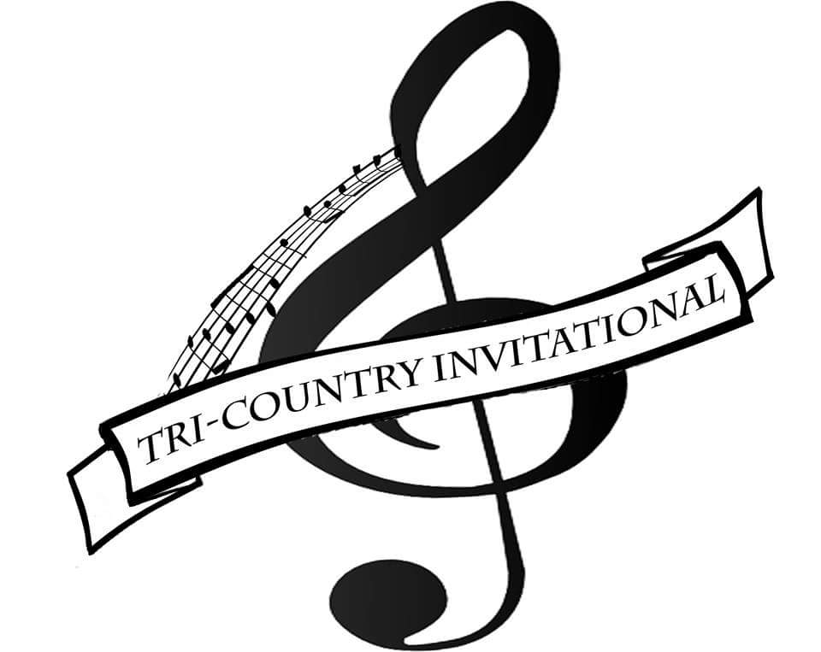

Classification of Bands
The total number of performers in each band will determine the classification.
Classes will be divided after all applications have been accepted. Tri-County Invitational will adhere to class sizes used in FMBC State Championships as closely as possible. Performing groups will be divided into 5 classes. Due to limited space, there will be a cap of 20 bands.
This is a prelims/finals format with the top 10 bands moving on to finals. The winner of each class and the next 5 highest scores will fill the allotted finals spots.

It is with great pleasure that we invite you to the 14th annual Tri-County Invitational Marching Band Festival. The festival will be September 29, 2018 at Chiefland Middle High School in Chiefland, Florida.

Tri-County Invitational

The Tri-County Invitational is traditionally a small band oriented festival that prides itself on creating an inspirational and positive musical experience for all students, directors, and spectators. However, this year we are opening up to 4A and 5A bands. We have chosen to create a prelims/finals competition for all size bands.

Entries in the Tri-County Invitational are for bands in the 1A-5A classifications. Size will be determined by total number of performers and will adhere to class sizes used in FMBC State Championships. There will be a cap of 20 performing groups due to limited space.

The festival will begin at approximately 9:00 a.m. beginning with the smallest classification and moving to the largest. Awards and critique will begin after the last band’s performance. Finals will begin approximately 6:00 p.m. with awards after Chiefland’s exhibition performance. The finals performance order will be the last 5 in (by overall score), followed by the winners of each class (by overall score)

A variety of awards will be distributed, which include: Place in Class, Caption awards for Proficient, Superior, and Distinguished ratings, Best in Class awards, Best Overall awards, 2nd Runner-up, 1st Runner-up, and Grand Champion specialty trophies.

FMBC format of rules will be in effect for this festival.

Performance placement is chosen by the earliest postmark on the returned application.
A festival fee of $150.00 will be assessed to each band, checks payable to CMHS Band. Festival fee is non-refundable.

AWARDS
All Bands Will Receive Participation Plaques
Proficient Ratings
Superior Ratings
Distinguished Ratings
Music
Visual
General Effect
Percussion
Auxiliary\Colorguard

Best in Class
MUSIC
M&M
GE
PERCUSSION
AUXILLARY\GUARD

Best Overall
Music
M&M
GE
Percussion
Auxiliary/Guard

Special Trophies for 2nd Runner-up, 1st Runner-up, and Grand Champion

Tri-County
Invitational
Please Write Legibly!!
Director’s Name: _________________________
Name of Band: ___________________________
School Name: ____________________________
Band Website: ____________________________
School Address: ___________________________
____________________________
Phone#: _________________________________
Director’s Cell: ____________________________
# of Performers: __________
Total #: _____________

Director’s email address
_____________________________________

Band Director Signature
_____________________________________

Please mail this application form and a non-refundable registration fee of $150.00 payable CMHS Band to:
Chiefland Middle High School
808 North Main Street
Chiefland, FL 32626
All entries must be received by
September 14th.
For further questions please do not hesitate to call Band Director: Chad Hodges @ 352-222-2213, or email @ chad.hodges@levyk12.org
We look forward to seeing your band!

